**Chapter I**

**INTRODUCTION**

In this present generation, most of the people depends on a machine and other computerized system in any companies. The common problems faced by the people is lack of information in updating their different activities. Unfortunately, most of Information kiosks are machines that can disseminate information and handle transactions.

The Binalbagan LGU information kiosk system identified in this study were used to provide information for updating government’s activities in every department and also the name of the officer in that department if what is the position and what is the job of that staff . For kiosks project that provides information. The system aim goals in this project is to manage database for municipal activities, Provide quick access of information, Give convenience to the user by providing relevant useful information, Create user friendly system. These goals can be accomplished with the help of an information kiosk system. With the system around, you can have complete information for every activity you want to know. Every task can also be performed in a quick manner. With a Kiosk information system, you can have you calendar of activities that can really help updating the employees. Through this, your ultimate aim of giving exact information can be easily reached. And if you want to transact in that department we make the system to easy to know the name of that personnel and what is the task they give to them.

In changing a new technology are issues that may support or be obstacles to a successful kiosk system. Beyond complete information, the kiosk should include information on government employee activities and programs. This research showed that most of the kiosk systems can include the ability to inform employees and that’s why employee have no reason to attend in every programs of the municipality. From a municipality perspective, a well-designed interface screen can be an additional user friendly feature. A continuous display of updated information about the activities will be provided through the kiosk system at the side of the gate or beside the guard house. The kiosk system will feature service messages such as emergency information in changing the schedule of activities.

**Objectives of the Study**

The study aims to develop the Binalbagan LGU Information Kiosk System to improve the municipality. The system is intended the municipality current process through automated to ensure user’s satisfaction. The said study could help to manage their information activities and to lessen their time in giving their service to the users. This can be help the individuals whose involve in the information kiosk.

**Specific Objectives**

●To develop a system that can inquire information via kiosk.

●To have a secured list of information.

●To elevate the Binalbagan LGU regarding to their information strategy.

●To give convenience to the user by providing relevant useful information.

**Purpose and Description**

The purpose of the proponents is to developed system is to help the people and personnel of Binalbagan LGU in terms of inquiring the information of the department.

The system will display the information of the department of the Binalbagan LGU as well as the personnel can use it. The said system will assure a proper information to every user of Binalbagn LGU Department and to avoid long transaction. Also, the system aims to lessen the difficulties in terms of gathering information.

The server run to every data into the database and the system will organize and process all the data input. By the use of this system, the possibilities to occur arguments since inevitable there is transact the information will be gathered.

**Scope and Limitation**

The system Non-Web Based of Binalbagan LGU Information Kiosk will handle the viewing, updating of the information of any department in Binalbagn LGU. A faster process of the said matters will be recognized until this system is implemented most importantly the system will store the data for the future.

**Significance of the Study**

Binalbagan LGU Information Kiosk System will be significant to the people whose involve in this system. With the help of this system, the users now are updated in an early time of information. That is why this study is conducted to build such systems reliable and cheaper enough to be trusted by the user and municipality**.**

**Staff/ Personnel**- The staff or other personnel will help the residence who is responsible for keeping the information to keep it safety in property.

**Client** - It would be easy for them to transact because there is a system that have Department Information wherein they can view the all information of the department.

**Admin-** this term refers to the person who recording the name of the user who login.

**Definition and terms**

**Automated**:

* In this study, the proponents defined this as to run or operate the kiosk with the use of computer to minimized manpower.

**Computerized:**

* In this study, the proponents define this as to elevate the municipality from their existing system by the use of computer

**Encode:**

-in this study, the proponents define this as to convert (a message) from plain text into code.

**Inquiry**:

-In this study, the proponents define this as seeking for information by asking questions.

**System:**

* In this study, the proponents define this as an application or a program that can be executed in the computer

**Chapter II**

**REVIEW OF RELATED LITERATURE AND PRIOR ARTS**

In this chapter refers to the background of the study of Binalbagan LGU Information Kiosk on how the infrastructure is build and how they manage the processes in each transaction. In this research also discuss the related foreign and local literature that is related in this study.

**RELATED CONCEPTS**

The chapter deals the different literatures and studies that where conducted for the research to understand more the system that are relevant and similar to the present study. By the use of this system we can easily understand the develop effective system for Information Kiosk

**LOCAL RELATED LITERATURE**

**IGACOS –** Job seekers from the island Garden City of Samal (IGACOS) can now access to Job Search Kiosk RD Joffrey M. Suyao leds the launching and turn-over to the local Government on September 7.

The Job Search Kiosk is an information portal designed by DOLE to provide information on employment and livelihood opportunities for free. With the updated Job Search Kiosk jobseekers may now search and apply for local or government job opportunities, register and post their skills, job matching, and get updates on other employment-related information. Also with its features more users can be accommodated, aside from jobseeker, employers and those who want career advancement the kiosk can be of use.

**Information Kiosk System for Philippine International Convention Center** – An information kiosk is developed in a public venue to give people self -service access to products and service. Kiosk are most often deployed in situations where a problem can be solved by giving people access to self -service tools. The information kiosk system for Philippine International Convention Center is a system developed aimed to guide and give information about the convention center. It was developed to help the attendants (e.g employee, visitors and admin) who were considered as the service priority of system. C# is the primary language used by the proponents to develop the system and MySQL for the database of the system’s records, the proponents used Adobe Flash CS5 for creating animations for the system. The primary objectives of the Information Kiosk system for PICC is to give a better service quality, ease of use and usefulness for convention center.

**Stand Alone Kiosk** – are electronic information stations capable of presenting a large amount of information using computer and touch screen or mouse for navigation kiosk are similar automatic teller machines, offering menus for interaction between a person and a computer Information is provided through a presentation that invites viewers to ask questions or direct the flow of Information. Software used in kiosk is highly specialized storing information on hard drives replaceable disks or through internet connections that allow retrieval of specific information based on directions from the user. Computer hardware requirements are fairly minimal, requiring relatively simple computer equipment. However, they must be made very rugged with easy to use interface components to provide for expected use.

**Public Participation Guide: Information Kiosks –** the advancement in information and communication technology (ICT) has garnered much interest in various fields. Tourism arena is one of the many fields in which ICT has become a subject of interest. Although in the late 90’s and in the early 21st century virtual tourism was predicted to have a major impact, traditional visit to places of attraction still remains popular. Therefore, the visitors appreciation and knowledge on certain places of attraction may improve through an integration of virtual tourism into a conventional physical movement. This will later could help induce further interest to visit. This integration can take in my many forms. One of the many significant approaches to this method is to deploy an ICT based information kiosk. Adapting the intrinsic value of information through the information kiosk however, requires more than just the technology. Social norms and user behavior has to be adequately studied in order to better understand the visitors intention and likelihood to use such Technology. Perhaps, the deployment of such technology is viewed as a catalyst to lure interest among visitors to heritage sites. Therefore, understanding the social behavior among visitors would contribute useful information on the technical aspects of the kiosk such ass design, concept and content. Several theories of social behavior are studied and the most applicable theory is used to explain the intention and the actual use of the kiosk.

**FOREIGN RELATED LITERATURE**

**Information Kiosk in Singapore –** the information kiosk of the past were dedicated machine, huge, costly, and designed mainly for the purpose of information retrieval and expensive to update. Today’s information kiosk, however, uses a multimedia PC which is housed in a close-fitting casing. Placed in public areas or exhibition, interactive kiosk are increasingly being used to disseminate, access, process, and collect information and/or perform transaction (financial or non-financial). This paper examined the various types of information kiosk in implementation in Singapore. A model in a form of a matrix is designed to map the various types of information kiosk.

**Information Kiosk in India –** kiosk info solutions started of as a touch screen kiosk solution provider by a team as well qualified experienced professional with an aim of offering PROMPT & QUALITY services requires by the customers. Our aim is to give the best value for our customer’s money, we do this by giving products and services of excellent quality at reasonable prices. We believe that hundred percent customer satisfaction must be the ultimate goal of any business.

**NFC Kiosk in Japan –** in japan, NFC (more precisely NFC-F which is different from NFC-A and –B used in the U.S) has been enthusiastically adopted nationwide over the last 10 years. Virtually all commuters in the major metropolitan areas of japan use NFC to pay their fares. Consumer can make payments using their NFC card at many locations including convenience stores, newsstands, restaurants, various retailers and vending machines. Almost 60 percent of cell phones – more than 70 million units in the market including recent android smartphones – are NFC-enabled.

**Information Kiosk in Belgium** – the author wish to thank Mr Xavier Dillen for data collection. They thank the firms that participated in the research. They would also like to thank the two anonymous reviewers and the editor providing valuable feedback on an earlier version of the article.

**TABLE OF COMPARISON**

Table 1. Non-Web Based Binalbagan LGU Information kiosk

The table shows the list of prior system both foreign and local systems and different features that compare on the features of Binalbagan LGU Information Kiosk.

|  |  |  |  |  |  |  |
| --- | --- | --- | --- | --- | --- | --- |
| Related  Prior  Art | Features | | | | | |
|  | User Friendly | Connectivity | Scheduling | Web-base | Time  Tabling | Security |
| Igacos | YES |  |  |  |  | YES |
| Stand Alone Kiosk | YES |  |  |  |  | YES |
| Information Kiosk in India | YES |  |  |  |  | YES |
| Information Kiosk in Belgium | YEs |  |  |  |  | YES |

Figure 1. shows the comparison of related application and system, this shows what are existing application and the system that can be compare to develop the project. This includes their features such as connectivity, security and applications.

**Chapter III**

**RESEARCH DESIGN AND METHODOLOGY**

This chapter presents the research design and methodology of the proponent’s system.

**Research Design**

This study is a descriptive – developmental research on the development of Non-Web Based Binalbagan LGU Information Kiosk for Carlos Hilado Memorial State College-Binalbagan Campus, Enclaro Binalbagan, Negros, Occidental.

The object-oriented system Development life is the model used by the proponents for the development of the system since it is waterfall as it met the the stages of the software development life cycle. The continuous cycle helps to furnish the propenents system drive through by the participation of the client which will be the person who’ll be using the system.

Table 3. ISO/IEC and McCall’s Evaluation Numerical and Descriptive Interpretation.

|  |  |
| --- | --- |
| **Numerical Rating** | **Descriptive Interpretation** |
| 5 | Very Good |
| 4 | Good |
| 3 | Average |
| 2 | Fair |
| 1 | Poor |

**Data Gathering Procedure**

The proponents asked for permission to conduct initial interview and observation on the person in charge of the Staff/Personnel of Binalbagn LGU to gather information to invent decision and plans to yield software that will furnish or to reach their expectation of the client and also guides for a well-maintained software

**Agile System Development Life Cycle**

The Agile system, is an approach that is intended to facilitate the development of the system. The Agile are thought to work well in situations in which complicated information system are undergoing continuous maintenance.

Figure 1. Agile SDLC Model

Figure 1. Display the process of software development that should be done in order to reach the expectation level of the system. The Agile system has five important stops needed to the accomplish in order produce a system.

**Analysis**

In analysis, the proponent conduct a research and interview on the staff of LGU. The proponent know that the information on each Department can easy use in the resident of Binalbagan. The proponent discuss about the problem on the LGU and give solution, they give appropriate framework process to provide an easy work to them.

**Context Diagram**

The context Diagram shows the general flow of processes of the developed system where an entity concerned is connected to a main process.

Admin

Manage Information

Binalbagan LGU Information Kiosk

Record the name of the user.

View Information of Department

Input department of LGU

User

Figure 2. Context Diagram of Binalbagan LGU Information Kiosk

Figure 2 shows the general processes of the developed system. It also demonstrates the viewing information and recording name and the expected process output of the system.

All the concept of this study is applied in this diagram to help the workers in having this Information kiosk in terms of viewing information.

**Data Flow Diagram**

The data flow diagram illustrates the flow of data input requirements and processed output

of the developed system.

**11**

3

Department 

2

Login

View Department

Admin

Restored Name of the user

View Information

Login

Update Information

1

User

5

Update Information

4

Department Information

Figure 3. Data Flow Diagram of Developed System

Figure 3 shows the entire data flows, the processes, input requirements, processed output and the storage of developed system.

**Use Case Diagram**

The use case diagram shows the user’s interaction with the system and its relationship between different use cases and the user is involved.

hahhh

Binalbagan LGU Information kiosk

User

Admin

Figure 4. Use Case Diagram of the proponents developed system.

Figure 4 shows the task that the actor must be done in order to implement the system. As the figure shows, the admin and the user perform in order for the system implement. Its job are to manage and adding information.

The correspondents use case description for the above actors are:

• Admin – the one who will going to use this system by recording the name of the user.

• User – the one who use this system for viewing information in binalbagan LGU.

**Use Case Description**

The table below describe the function, conditions and alternative flow to be met of the actor in the use case diagram.

Table 5. Manage Information

|  |  |
| --- | --- |
| Use Case Name | Manage Information |
| Primary Actor | Admin |
| Description | Managing Information |
| Pre-Condition | Admin – must be manage all the department information. |
| Post-Condition | Admin - record the name of the user. |
| Main Success Success | Admin – After the recording of the name they have the list of the user. |

Table 6. Add, Update Information

|  |  |
| --- | --- |
| Use Case Name | Add, update information |
| Primary Actor | Admin |
| Description | Adding and Updating |
| Pre-Condition | Admin – must be add information and update information. |
| Post-Condition | Admin – the admin will secure the information. |
| Main Success Scenario | Admin – after the admin add and update the information, the information will be stored in the Kiosk. |

Table 7. Manage User

|  |  |
| --- | --- |
| Use Case Name | Manage User |
| Primary Key | User |
| Description | Management of subject information |
| Pre-Condition | User – must manage the information that they needed. |
| Post-Condition | User – the user will know how they do. |
| Main Success Scenario | The user will get the information of the department. |

Table 8. Viewing Information

|  |  |
| --- | --- |
| Use Case Name | Viewing Information |
| Primary Key | User |
| Description | User will view information. |
| Pre-Condition | User – User can get information of the department. |
| Post-Condition | User – the user will get the detail of the department. |
| Main Success Scenario | User – the of the user will stored in the admin. |

Table 9. View and Record name

|  |  |
| --- | --- |
| Use Case Name | View and Record Name |
| Primary Key | Admin |
| Description | Admin – need to record the name of the user. |
| Pre-Condition | Admin – the name of the user will stored. |
| Post-Condition | Admin – will add, update the department information. |
| Main Success Scenario | The name of the user will be stored. |

Table 10. Display Department

|  |  |
| --- | --- |
| Use Case Name | Display Department |
| Primary Key | Admin  User |
| Description | Admin - The admin will display the department information.  User - The user will display the department. |
| Pre-Condition | Admin - The admin will add, update the department information.  User – The user will get department information |
| Post-Condition | Admin - The admin will display department information.  User – the user will display department. |
| Main Success Scenario | Admin – Updated information.  User – Get information. |

Table 11. Login

|  |  |
| --- | --- |
| Use Case Name | Login |
| Primary Key | User |
| Description | User - The user must login |
| Pre-Condition | User - The name of the user will record |
| Post-Condition | User – will display department. |
| Main Success Scenario | Get Information |

**Activity Diagram**

The activity diagram shows the interactive flow of activities done by the actor of the developed system.

**Manage User**

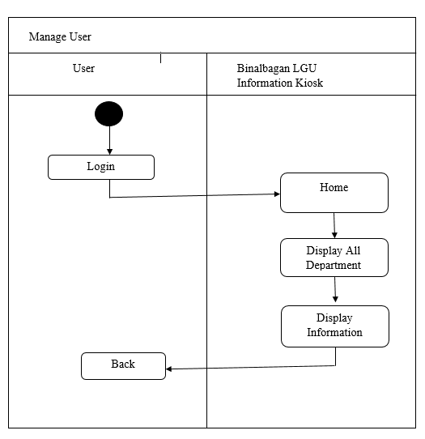

Figure 5. Manage User Activity Diagram of the developed system shows the step on how user manage it.

**Login**

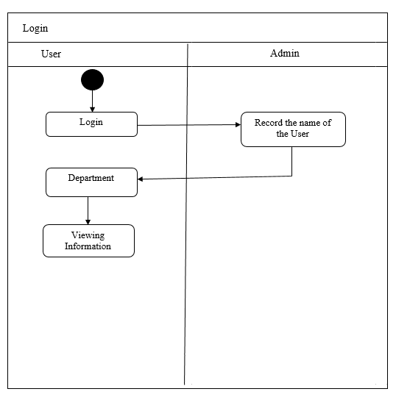

Figure 6. Login Activity Diagram of the developed system

Shows the steps for user to login.

**Decomposition Chart**

Decomposition chart shows the break down process and its sub-process of the whole system.

**Binalbagan LGU Information Kiosk**

Tourism

Manage Admiin

BIR

POST OFFICE

Mayor’s office

Client

Admin

Comelec

DSWD

Add

Manage Depar

tment Informa

tion

Add

Manage

Add

Add

Add

Add

Add

Archives

Display

Display

ADDnve

Display

Display

Display

Display

Update

Update

Display

Update

Update

Update

Update

Archive

Archive

Archive

Archive

Archive

Archive

Update

Restore

Name

Figure 7. Operational Framework

Figure 7. shows the breakdown processes and its sub-processes of the developed system. Every process has been labelled and mark to equate the functionality of the whole system.

**Operational Frameworks**

As every steps done, the proponents review the information inputs and the processes in the proposed system for us to know what we could change to remove or add certain functionality or feature.

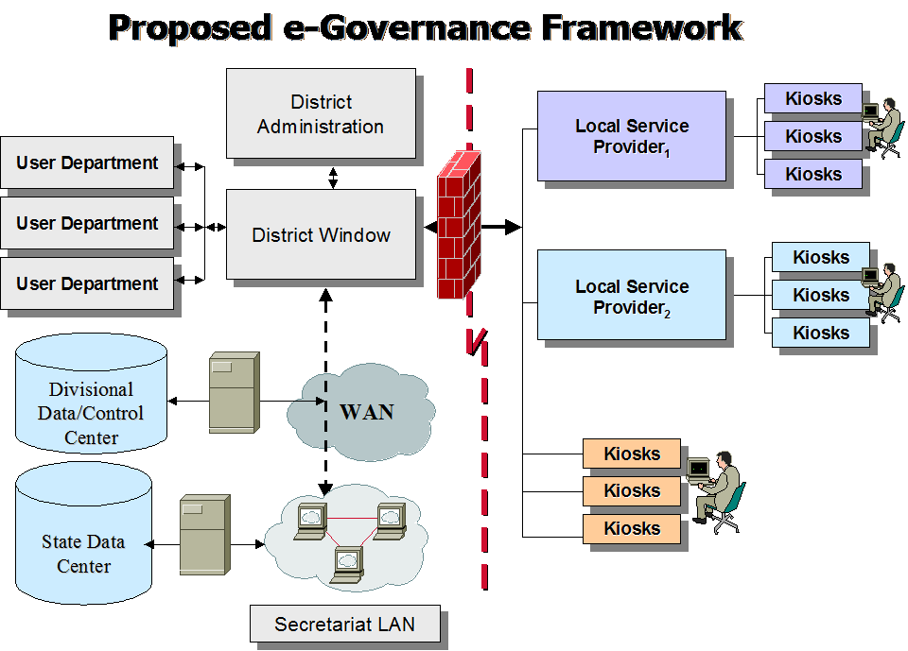

Figure 8. Operational Frameworks

Figure 8. shows the operational framework on the system was composed of Staff/Personnel, PC and the admin updates the information of the department that stored in the Kiosk. The information inside the kiosk will be updated whwn the department add information.

**Recommended Hardware Specification**

For Binalbagan LGU Information Kiosk is develop and run in a perfect function.

First the client must implement the following hardware specification.

* Microsoft Windows 7 Professional/Windows 8
* 4GB, 64-bit Processor
* 500 Gigabyte Hard Drive
* Intel Core i3 or Equivalent
* 40 Gigabytes Hard Drive (for Backup)

**Recommended Software Specification**

• MySQL, Apache

• HeidiSSQL

• Java

**Entity Relationship Diagram**

Relationship database management system (RDMS) is a database management system (DBMS) based on relation model or data. In conformity, the Entity Relation Diagram shows the relationship and the connection of all tables in the connection of all the in the database in working system.

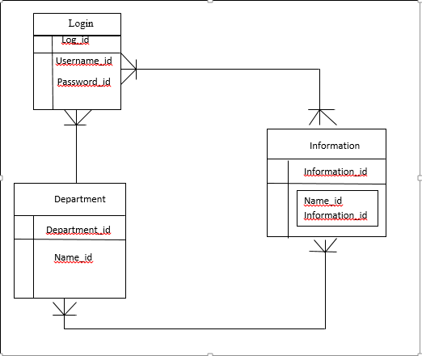

Figure 9. Shows the connection of all tables in the database requires specific information in order to work the system.

**Data Dictionary**

The table below show the list of all tables and the data stored in the database on the Binalbagan LGU Information Kiosk. It provides the attributes, data types and also the description for each fieldnames to recognize the data being stored in the database.

Table 12. Login

|  |  |  |  |
| --- | --- | --- | --- |
| Fieldname | Description | Type | Length |
| ID | User ID | INT | 10 |
| Username | Username  Identification | VARCHAR | 50 |
| Password | Password | VARCHAR | 50 |

**Gantt Chart**

The Gantt chart assess the proponents with the effective project management throughout the whole process. It stated there of how long process will take the needs an efficient and effective time management. The Gantt chart also figured out the minimum developing time of the proposed project.

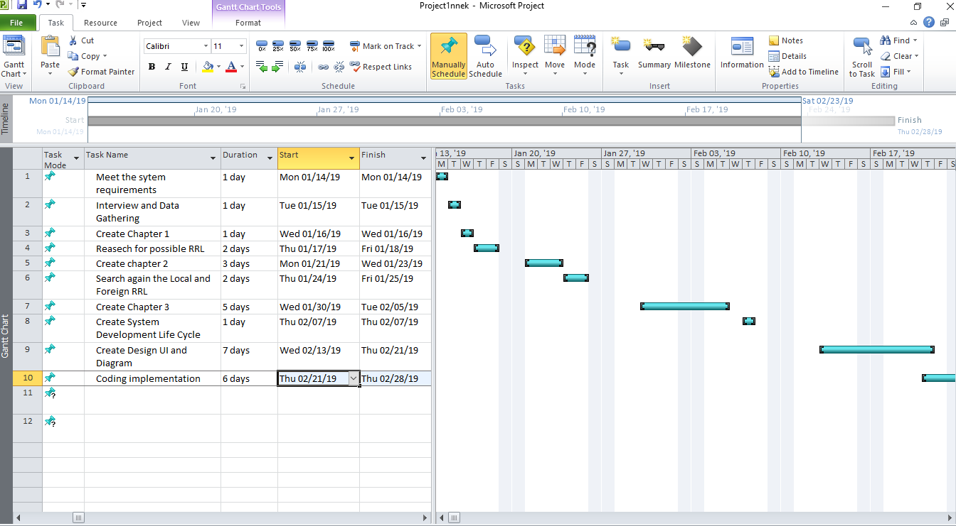

Figure 10 Gantt Chart shows the project team started January 22, 2019. This was follow by the series of activities in regards to the system development. The process was aligned with the system development life cycle phase which are analysis, planning, design, implementation, evaluation and testing. This tool guides the project team on the different activity that needs to be done in succeeding days.

Time Table

The time table shows the tasks by the proponents.

Table 17. Time Table

|  |  |  |  |
| --- | --- | --- | --- |
| Task | Date Started | Date Finished | Assigned Members |
| Meet the system requirements | 14/01/19 | 14/01/19 | Jessamie Alarcon  Jessa mae Aguillon  Myra Omen |
| Create Chapter 1 | 16/01/19 | 16/01/19 | Jessamie Alarcon  Jessa mae Aguillon  Myra Omen |
| Research for possible RRL | 17/01/19 | 18/01/19 | Myra Omen |
| Create Chapter 2 | 21/01/19 | 23/01/19 | Jessamie Alarcon  Jessa mae Aguillon  Myra Omen |
| Search Local and Foreign RRL | 24/01/19 | 25/01/19 | Jessamie Alarcon  Jessa mae Aguillon  Myra Omen |
| Finalizing Chapter 2 | 28/01/19 | 28/01/19 | Jessamie Alarcon  Jessa mae Aguillon  Myra Omen |
| Create Chapter 3 | 30/01/19 | 05/02/19 | Jessamie Alarcon  Jessa mae Aguillon  Myra Omen |
| Finalizing Chapter 3 | 04/02/19 | 07/02/19 | Jessamie Alarcon  Jessa mae Aguillon  Myra Omen |
| Create Design UI and Diagram | 13/02/19 | 20/02/19 | Myra Omen  Jessamie Alarcon  Jessame Aguillon |
| Coding Implementation | 21/02/19 | 28/02/19 | Jessamie Alarcon  Jessa mae Aguillon  Myra Omen |
| Create PowerPoint for Oral Defense | 26/02/19 | 05/03/29 | Myra Omen |